School Management System
DATA BASE



Mansoor Ahmad Khan
Semester project
Course Code:
Session 2024 –2028

INSTITUTE OF MANAGEMENT SCIENCES

School Management System

PROJECT REPORT


1. Introduction to the working of the system:
A database model has been developed at IMSciences to efficiently manage student records, including information about students, departments, instructors, and courses. This system streamlines operations, supports queries, and ensures future scalability.

- Problems in the existing system:
A database model has been developed at IMSciences to efficiently manage academic records, encompassing information about students, departments, instructors, and courses. The system is designed to streamline administrative operations, facilitate complex queries, maintain data consistency, and support future scalability for institutional growth.
- Entity - Relation Diagram:
c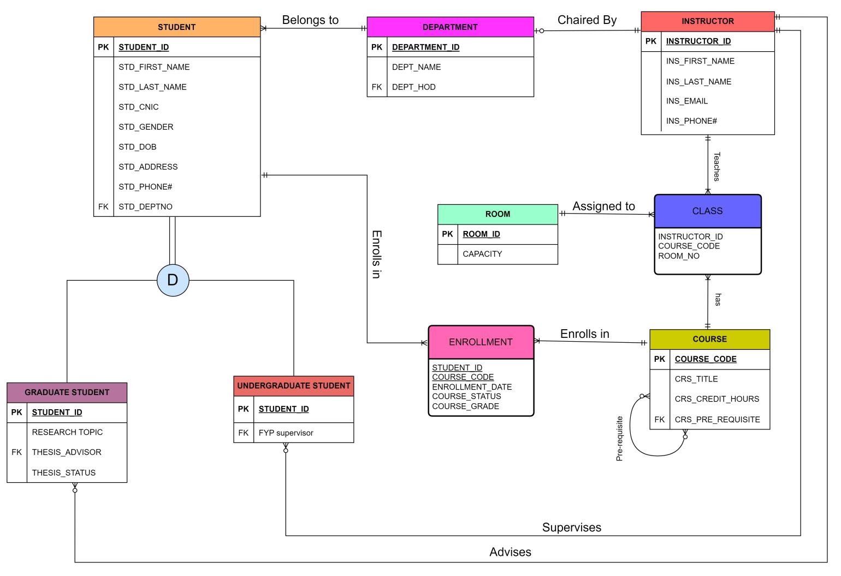

4. ERD Transformation

Student
A strong entity
Student (Student_ID, First_Name, Last_Name, CNIC, Gender, DOB, Address, Phone#, DeptNo)

Graduate Student
Student’s Subtype
Graduate Student (Student_ID, Thesis_Advisor_ID, Thesis_Status)

Undergraduate Student
Student’s Subtype
Undergraduate Student (Student_ID, FYP_Advisor_ID)

Department
Strong Entity
Department (DeptNo , Dept_Name , Dept_HOD)

Instructor
A regular entity
Instructor (Instructor_ID, First_Name , Last_Name, Email, Phone#)

Room
A regular entity
Room (RoomNo , Capacity)

Course
Recursive relation
Course (Course_Code, Course_Title, Credit_Hours, Pre_Requisite_ID)

Class
An associative entity
Class (Instructor_ID, Course_Code, RoomNo)

Enrollment
An associative entity
Enrollment (Student_ID, Course_Code, Enrollment_Date, Course_Grade, Status)
NOTE:
___________ Indicates primary key
Indicates foreign key

5. CONSTRUCTION OF RELATIONAL SCHEMA
- TOP DOWN APPROACH
- BOTTOM UP APPROACH

TOPDOWNAPPROACH
Identified entities:
- Student
  - Graduate students
  - Undergraduate students
- Instructor
- Department
- Course
- Room
- Class  Enrollment
Relations:
Student (Student_ID, First_Name, Last_Name, CNIC, Gender, DOB, Address, Phone#, DeptNo)
Graduate Student (Student_ID, Thesis_Advisor_ID, Thesis_Status)
Undergraduate Student (Student_ID, FYP_Advisor_ID)
Department (DeptNo , Dept_Name , Dept_HOD)
Instructor (Instructor_ID, First_Name , Last_Name, Email, Phone#)
Room (RoomNo , Capacity)
Course (Course_Code, Course_Title, Credit_Hours, Pre_Requisite_ID)
Class (Instructor_ID, Course_Code, RoomNo)
Enrollment (Student_ID, Course_Code, Enrollment_Date, Course_Grade, Status)

Normalization
Student (Student_ID, First_Name, Last_Name, CNIC, Gender, DOB, Address, Phone#, DeptNo) 1NF : Already in 1NF as there is no repeating group.
2NF : Already in 2NF as there is no Partial Functional Dependency. 3NF : Already in 3NF as there is no Transitive Dependency.
Graduate Student (Student_ID, Thesis_Advisor_ID, Thesis_Status)
1NF : Already in 1NF as there is no repeating group.
2NF : Already in 2NF as there is no Partial Functional Dependency. 3NF : Already in 3NF as there is no Transitive Dependency.

Undergraduate Student (Student_ID, FYP_Advisor_ID)
1NF : Already in 1NF as there is no repeating group.
2NF : Already in 2NF as there is no Partial Functional Dependency.
3NF : Already in 3NF as there is no Transitive Dependency.
Department (DeptNo , Dept_Name , Dept_HOD) 1NF : Already in 1NF as there is no repeating group.
2NF : Already in 2NF as there is no Partial Functional Dependency. 3NF : Already in 3NF as there is no Transitive Dependency.
Instructor (Instructor_ID, First_Name , Last_Name, Email, Phone#)
1NF : Already in 1NF as there is no repeating group.
2NF : Already in 2NF as there is no Partial Functional Dependency. 3NF : Already in 3NF as there is no Transitive Dependency.
Room (RoomNo , Capacity)
1NF : Already in 1NF as there is no repeating group.
2NF : Already in 2NF as there is no Partial Functional Dependency. 3NF : Already in 3NF as there is no Transitive Dependency.
Course (Course_Code, Course_Title, Credit_Hours, Pre_Requisite_ID)
1NF : A single course can have Multiple pre-requisites. So, there is a repeating group.
Shift the pre-requisite of course to another relation.
After removing repeating group:
Course (Course_Code, Course_Title, Credit_Hours)
Pre_Requisite_Course (Course_Code, Pre_Requisite_ID)
2NF : Already in 2NF as there is no Partial Functional Dependency. 3NF : Already in 3NF as there is no Transitive Dependency.
Class (Instructor_ID, Course_Code, RoomNo) Normalization:
1NF : Already in 1NF as there is no repeating group.
2NF : Already in 2NF as there is no Partial Functional Dependency. 3NF : Already in 3NF as there is no Transitive Dependency.
Enrollment (Student_ID, Course_Code, Enrollment_Date, Course_Grade, Status)
1NF : Already in 1NF as there is no repeating group.
2NF : Already in 2NF as there is no Partial Functional Dependency.
3NF : Already in 3NF as there is no Transitive Dependency.

Result:
Now all relations are in 3NF, there's no further normalization needed. This indicates that the relations are structured well, with minimal redundancy and efficient data organization.

BOTTOMUPAPPROACH

Bulky relation comprising all attributes:
Relation → {Student_ID, Std_First_Name, Std_Last_Name, Std_CNIC, Std_Gender, Std_DOB,
Std_Address, Std_Phone#, Std_DeptNo, DeptNo, Dept_Name ,Dept_HOD, Thesis_Advisor_ID,
Thesis_Status, FYP_Advisor_ID, Instructor_ID, Ins_First_Name , Ins_Last_Name, Ins_Email,
Ins_Phone#, RoomNo , Capacity, Course_Code, Course_Title, Credit_Hours, Pre_Requisite_ID,
Enrollment_ID, Enrollment_Date, Course_Grade, Status}
The relation consists of all the attributes in our present ERD. Now, we will construct a sub-relation from above and perform normalization.

Relation
Student(Student_ID,STD_First_name,Last_name,Std_CNIC,Gender,DOB,Address,Phone#,Deptno)
1NF : No repeating Group
2NF : No Partial Functional Dependency
3NF : No Transitive Dependency
Subtypes:
Graduate Student (Student_ID, Thesis_Advisor_ID, Thesis_Status)
1NF : There is no repeating group
2NF : Already in 2NF as there is no Partial Functional Dependency. 3NF : Already in 3NF as there is no Transitive Dependency.
Undergraduate Student (Student_ID, FYP_Advisor_ID)
1NF : Already in 1NF as there is no repeating group.
2NF : Already in 2NF as there is no Partial Functional Dependency. 3NF : Already in 3NF as there is no Transitive Dependency.
DEPARTMENT (Deptno,Dept_Name,Dept_HOD)
1NF : Already in 1NF as there are no multivalued attributes.
2NF : Already in 2NF as there is no Partial Functional Dependency. 3NF : Already in 3NF as there is no Transitive Dependency.

Instructor (Instructor_ID, First_Name , Last_Name, Email, Phone#) 1NF : Already in 1NF as no duplicating values.
2NF : Already in 2NF as atomic primary key.
3NF : Already in 3NF as no non-key attributes determine other attributes.
Room (RoomNo , Capacity)
1NF : No duplicate data as there is only one Primary key 2NF : Already in 2NF as there is no Partial Functional Dependency.
3NF : Already in 3NF as there is no Transitive Dependency.
Course (Course_Code, Course_Title, Credit_Hours, Pre_Requisite_ID) There may be multiple pre-requisite for one course.
So,It does not hold 1NF requirements
After 1NF
Course(Course_Code, Course_Title, Credit_Hours)
Course_Pre_Req (Course_Code, Pre_Requisite_ID)
2NF : Already in 2NF as there is no Partial Functional Dependency. 3NF : Already in 3NF as there is no Transitive Dependency.
Class (Instructor_ID, Course_Code, RoomNo)
1NF : Already in 1NF as there is no repeating group.
2NF : Already in 2NF as there is no Partial Functional Dependency. 3NF : Already in 3NF as there is no Transitive Dependency.
Enrollment (Student_ID, Course_Code, Enrollment_Date, Course_Grade, Status) 1NF : Already in 1NF as there is no repeating group.
2NF : Already in 2NF as there is no Partial Functional Dependency.
3NF : Already in 3NF as there is no Transitive Dependency.

Connectivity Table:
Entity | Relationship | Connectivity | Entity
Student | Is a | 1:1 | Graduate Student
Student | Is a | 1:1 | Under Graduate Student
Department | Has | 1:M | Student
Instructor | Has | 1:1 | department
Instructor | Has | 1:M | Graduate Student
Instructor | Has | 1:M | Under graduate student
Student | Has | 1:M | Course
Course | Has | 1:M | Course
Course | Has | 1:M | Student
Room | Has | 1:M | Class
Instructor | Has | 1:M | Class
6. Description of relations
Student
Attribute | Type | Size | Constraints
STUDENT_ID | CHAR | 10 | PRIMARY KEY
FIRST_NAME | VARCHAR2 | 20 | NOT NULL
LAST_NAME | VARCHAR2 | 20 | NOT NULL
CNIC | CHAR | 13 | UNIQUE
GENDER | CHAR | 1 | M OR F
DOB | DATE
ADDRESS | VARCHAR2 | 50
PHONE# | CHAR | 13 | NOT NULL , UNIQUE
DEPTNO | NUMBER |  | REFERENCE TO DEPARTMENT

Graduate Student
Attribute | Type | Size | Constraints
STUDENT_ID | CHAR | 10 | PRIMARY KEY, REFERENCE TO STUDENT
THESIS_ADVISOR | CHAR | 10 | REFERENCE TO INSTRUCTOR
THESIS_STATUS | VARCHAR2 | 20 | ‘COMPLETE’ OR ‘IN PROGRESS’
Under Graduate Student
Attribute | Type | Size | Constraints
STUDENT_ID | CHAR | 10 | PRIMARY KEY, REFERENCE TO STUDENT
FYP_ADVISOR | CHAR | 10 | REFERENCE TO INSTRUCTOR
Department
Attribute | Type | Size | Constraints
DEPTNO | NUMBER |  | PRIMARY KEY
DEPTNAME | VARCHAR2 | 50 | NOT NULL
HOD | CHAR | 10 | REFERENCE TO INSTRUCTOR
Instructor
Attribute | Type | Size | Constraints
INSTRUCTOR_ID | CHAR | 10 | PRIMARY KEY
FIRST_NAME | VARCHAR2 | 20 | NOT NULL
LAST_NAME | VARCHAR2 | 20 | NOT NULL
EMAIL | VARCHAR2 | 30 | UNIQUE
PHONE# | CHAR | 13 | NOT NULL , UNIQUE
Room
Attribute | Type | Size | Constraints
ROOMNO | NUMBER |  | PRIMARY KEY
CAPACITY | NUMBER |  | POSITIVE INTEGER
Course
Attribute | Type | Size | Constraints
COURSE_CODE | VARCHAR2 | 10 | PRIMARY KEY
COURSE_TITLE | VARCHAR2 | 50 | NOT NULL
CREDIT_HOURS | NUMBER |  | BETWEEN 0.5 AND 3

Pre_Requisite_Course
Attribute | Type | Size | Constraints
COURSE_CODE | VARCHAR2 | 10 | PRIMARY KEY, REFERENCE TO COURSE
PRE_REQ | VARCHAR2 | 10 | PRIMARY KEY, REFERENCE TO COURSE
Class
Attribute | Type | Size | Constraints
INSTRUCTOR_ID | CHAR | 10 | PRIMARY KEY, REFERENCE TO INSTRUCTOR
COURSE_CODE | VARCHAR2 | 10 | PRIMARY KEY, REFERENCE TO COURSE
ROOM_NO | NUMBER |  | REFERENCE TO ROOM
Enrollment
Attribute | Type | Size | Constraints
STUDENT_ID | CHAR | 10 | PRIMARY KEY, REFERENCE TO STUDENT
COURSE_CODE | VARCHAR2 | 10 | PRIMARY KEY,REFERENCE TO COURSE
ENROLLMENT_DATE | DATE
GRADE | CHAR | 1 | ‘A’,’B’,’C’,’D’ OR F
STATUS | CHAR | 4 | ‘PASS’ OR ‘FAIL’

7. CREATE TABLE statements for all relations
Student
CREATE TABLE Student
(
STUDENT_ID CHAR(10) CONSTRAINT pk_student PRIMARY KEY,
FIRST_NAME VARCHAR(20) CONSTRAINT nn_first_name NOT NULL,
LAST_NAME VARCHAR(20) CONSTRAINT nn_last_name NOT NULL,
CNIC CHAR(13) CONSTRAINT uq_cnic UNIQUE,
GENDER CHAR(1) CONSTRAINT ck_gender CHECK (GENDER IN ('M', 'F')),
DOB DATE,
ADDRESS VARCHAR(50),
PHONE CHAR(13) CONSTRAINT nn_phone NOT NULL,
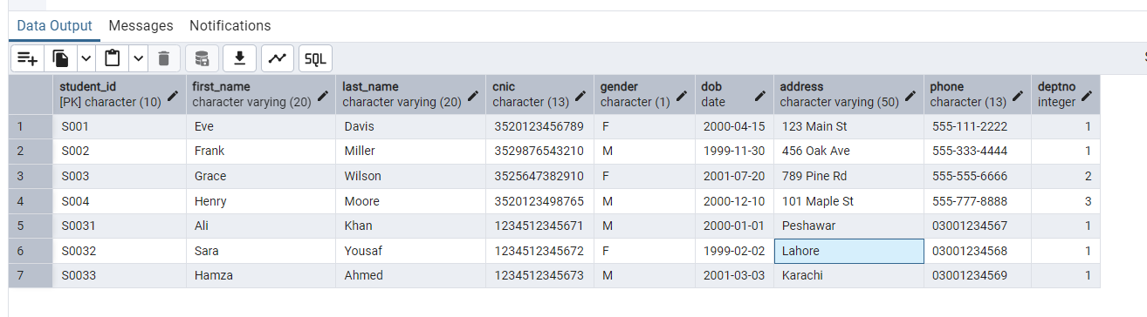
DEPTNO NUMBER CONSTRAINT fk_deptno REFERENCES Department(DEPTNO));

Graduate Student
CREATE TABLE Graduate_Student
(
STUDENT_ID CHAR(10) CONSTRAINT pk_graduate_student PRIMARY KEY REFERENCES
Student(STUDENT_ID),
THESIS_ADVISOR CHAR(10) CONSTRAINT fk_thesis_advisor REFERENCES
Instructor(INSTRUCTOR_ID),
THESIS_STATUS VARCHAR(20) CONSTRAINT ck_thesis_status CHECK
(THESIS_STATUS IN ('COMPLETE', 'IN PROGRESS')) );
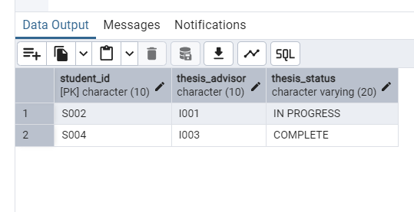
Under Graduate Student
CREATE TABLE Undergraduate_Student
(
STUDENT_ID CHAR(10) CONSTRAINT pk_undergraduate_student PRIMARY KEY REFERENCES Student(STUDENT_ID),
FYP_ADVISOR CHAR(10) CONSTRAINT fk_fyp_advisor REFERENCES
Instructor(INSTRUCTOR_ID)
);
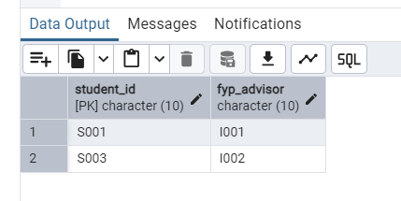
Department
CREATE TABLE department (
deptno INTEGER CONSTRAINT pk_department PRIMARY KEY,
deptname VARCHAR(50) NOT NULL CONSTRAINT nn_deptname,
hod CHAR(10) CONSTRAINT fk_hod REFERENCES instructor(instructor_id)
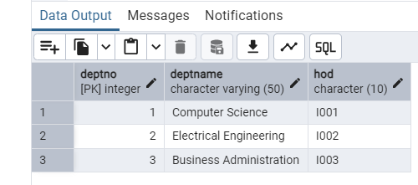
);

Instructor
CREATE TABLE instructor (
instructor_id CHAR(10) CONSTRAINT pk_instructor PRIMARY KEY,
first_name VARCHAR(20) NOT NULL CONSTRAINT nn_instructor_first_name,
last_name VARCHAR(20) NOT NULL CONSTRAINT nn_instructor_last_name,
email VARCHAR(30) CONSTRAINT uq_instructor_email UNIQUE,
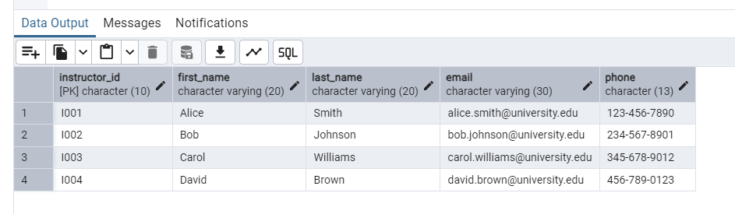
phone CHAR(13) NOT NULL CONSTRAINT nn_instructor_phone);

Room
CREATE TABLE room (
roomno INTEGER CONSTRAINT pk_room PRIMARY KEY,

capacity INTEGER CONSTRAINT ck_capacity CHECK (capacity > 0)
);
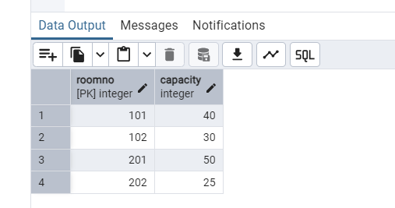

Course
CREATE TABLE Course
(
COURSE_CODE VARCHAR2(10) CONSTRAINT pk_course PRIMARY KEY,
COURSE_TITLE VARCHAR2(50) CONSTRAINT nn_course_title NOT NULL,
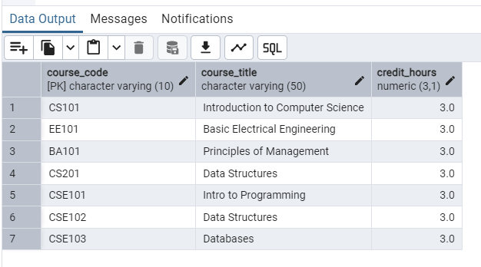
CREDIT_HOURS NUMBER CONSTRAINT ck_credit_hours CHECK (CREDIT_HOURS BETWEEN 0.5 AND 3) );

Pre_Requisite_Course
CREATE TABLE pre_requisite_course (
course_code VARCHAR(10) CONSTRAINT fk_course_code REFERENCES course(course_code),
pre_req VARCHAR(10) CONSTRAINT fk_pre_req REFERENCES course(course_code),
CONSTRAINT pk_pre_requisite_course PRIMARY KEY (course_code, pre_req));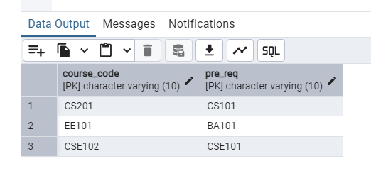

Class
CREATE TABLE class (
instructor_id CHAR(10) CONSTRAINT fk_class_instructor REFERENCES instructor(instructor_id),
course_code VARCHAR(10) CONSTRAINT fk_class_course REFERENCES course(course_code),
room_no INTEGER CONSTRAINT fk_class_room REFERENCES room(roomno)
CONSTRAINT pk_class PRIMARY KEY (instructor_id, course_code));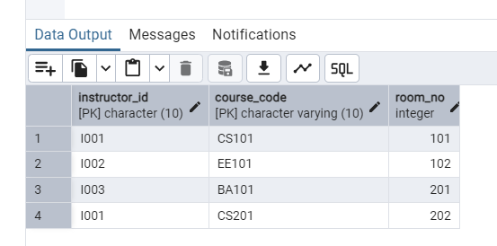

Enrollment
CREATE TABLE enrollment (
student_id CHAR(10) CONSTRAINT fk_enrollment_student REFERENCES student(student_id),
course_code VARCHAR(10) CONSTRAINT fk_enrollment_course REFERENCES course(course_code),
enrollment_date DATE,
grade CHAR(1) CONSTRAINT ck_grade CHECK (grade IN ('A', 'B', 'C', 'D', 'F')),
status CHAR(4) CONSTRAINT ck_status CHECK (status IN ('PASS', 'FAIL')),
CONSTRAINT pk_enrollment PRIMARY KEY (student_id, course_code)
);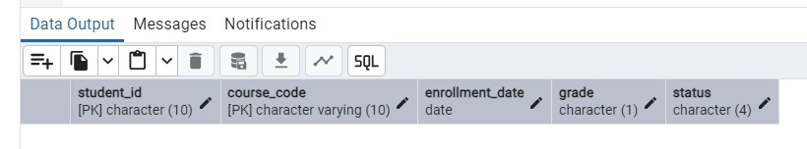

8. Views of relational schema
1. Student Details:
CREATE OR REPLACE VIEW student_details AS
SELECT
S.STUDENT_ID,
S.FIRST_NAME || ' ' || S.LAST_NAME AS FULL_NAME,
S.CNIC,
S.GENDER,
S.DOB,
S.ADDRESS,
S.PHONE,
D.DEPTNAME AS DEPARTMENT_NAME,
H.FIRST_NAME || ' ' || H.LAST_NAME AS DEPARTMENT_HEAD
FROM
Student S
JOIN Department D ON S.DEPTNO = D.DEPTNO JOIN Instructor H ON D.HOD = H.INSTRUCTOR_ID; select * from student_details

2. Enrollment Details
CREATE VIEW Enrollment_Details AS
SELECT
e.STUDENT_ID,
s.FIRST_NAME,
s.LAST_NAME,
e.COURSE_CODE,
c.COURSE_TITLE,
e.ENROLLMENT_DATE,
e.GRADE,
e.STATUS
FROM Enrollment e
JOIN Student s ON e.STUDENT_ID = s.STUDENT_ID JOIN Course c ON e.COURSE_CODE = c.COURSE_CODE select * from enrollment_details

3. Graduate Students Details:
CREATE OR REPLACE VIEW Graduate_Student_Details AS
SELECT gs.STUDENT_ID,
CONCAT(s.FIRST_NAME,CONCAT(' ',s.LAST_NAME)) "STUDENT NAME", s.CNIC,
s.GENDER,
s.DOB,
s.ADDRESS,
s.PHONE,
CONCAT(i.FIRST_NAME,CONCAT(' ',i.LAST_NAME)) "ÄDVISOR NAME", gs.THESIS_STATUS
FROM Graduate_Student gs
JOIN Student s ON gs.STUDENT_ID = s.STUDENT_ID
JOIN Instructor i ON gs.THESIS_ADVISOR = i.INSTRUCTOR_ID;
4. Pre-Requisite Courses Details:
CREATE OR REPLACE VIEW Pre_Requisite_Course_Details AS
SELECT
c.COURSE_TITLE AS COURSE_TITLE, prc2.COURSE_TITLE AS PRE_REQ_TITLE
FROM Pre_Requisite_Course prc
JOIN Course c ON prc.COURSE_CODE = c.COURSE_CODE
JOIN Course prc2 ON prc.PRE_REQ = prc2.COURSE_CODE;

9. Relational Data Model showing associations

Student
Student_ID
FirstName
LastName
CNIC
Gender
DOB
Address
PHONE#
DeptNo
Graduate
Student
Student_ID
Thesis_Advisor_ID
Thesis_Status
Under
Graduate
Student
Student_ID
FYP_Advisor
Instructor
Instructor_ID
FirstName
LastName
Email
Phone#
Department
DeptNo
Dept_Name
HOD
Course
Course_Code
Course_Title
Credit_Hours
Pre-Requisite
Course
Course_Code
Pre_Req
Room
RoomNo
Capacity
Class
Instructor_ID
Course_Code
RoomNo
Enrollment
Student_ID
Course_Code
Enrollment_Date
Grade
Status

10. Five Common Reports

1. QUERY TO RETRIEVE STUDENTS WHOSE THESIS IS COMPLETE

SELECT

S.FIRST_NAME || ' ' || S.LAST_NAME AS NAME,

I.FIRST_NAME || ' ' || I.LAST_NAME AS ADVISOR,

G.THESIS_STATUS

FROM STUDENT S

JOIN GRADUATE_STUDENT G ON G.STUDENT_ID = S.STUDENT_ID

JOIN INSTRUCTOR I ON I.INSTRUCTOR_ID = G.THESIS_ADVISOR

WHERE G.THESIS_STATUS = 'COMPLETE';

2. QUERY TO RETRIEVE ROOMS THAT ARE FREE YET

SELECT R.ROOMNO, R.CAPACITY

FROM ROOM R

LEFT JOIN CLASS C ON R.ROOMNO = C.ROOM_NO

WHERE C.ROOM_NO IS NULL;

3. QUERY TO RETRIEVE DEPARTMENT ID ,NAME ,HEAD AND NUMBER OF STUDENTS IN THAT DEPARTMENT

SELECT

d.DEPTNO,

d.DEPTNAME,

i.FIRST_NAME || ' ' || i.LAST_NAME AS HEAD_NAME,

COUNT(s.STUDENT_ID) AS STUDENT_COUNT

FROM Department d

JOIN Instructor i ON d.HOD = i.INSTRUCTOR_ID

LEFT JOIN Student s ON d.DEPTNO = s.DEPTNO

GROUP BY d.DEPTNO, d.DEPTNAME, i.FIRST_NAME, i.LAST_NAME;

4. LIST INSTRUCTORS WHO ARE SUPERVISING AN FYP

SELECT DISTINCT

I.INSTRUCTOR_ID,

I.FIRST_NAME || ' ' || I.LAST_NAME AS NAME

FROM Instructor I

JOIN Undergraduate_Student U ON I.INSTRUCTOR_ID = U.FYP_ADVISOR;

5. STUDENT WHO ARE FAILED IN ANY SUBJECT

SELECT

S.STUDENT_ID,

S.FIRST_NAME || ' ' || S.LAST_NAME AS NAME,

C.COURSE_TITLE,

I.FIRST_NAME || ' ' || I.LAST_NAME AS TEACHER_NAME

FROM STUDENT S

JOIN ENROLLMENT E ON S.STUDENT_ID = E.STUDENT_ID

JOIN COURSE C ON C.COURSE_CODE = E.COURSE_CODE

JOIN CLASS CL ON E.COURSE_CODE = CL.COURSE_CODE

JOIN INSTRUCTOR I ON I.INSTRUCTOR_ID = CL.INSTRUCTOR_ID

WHERE E.GRADE = 'F';

11. Procedures
1. PROCEDURE TO SHOW THE RESULT OF SPECIFIC STUDENT CREATE OR REPLACE PROCEDURE Student_Result(p_STUDENT_ID CHAR)
LANGUAGE plpgsql
AS $$
DECLARE
rec RECORD;
no_enrollments BOOLEAN := TRUE;
BEGIN
FOR rec IN
SELECT e.COURSE_CODE, c.COURSE_TITLE, e.GRADE, e.STATUS
FROM Enrollment e
JOIN Course c ON e.COURSE_CODE = c.COURSE_CODE
WHERE e.STUDENT_ID = p_STUDENT_ID
LOOP
no_enrollments := FALSE;
RAISE NOTICE 'Course Code: %', rec.COURSE_CODE;
RAISE NOTICE 'Course Title: %', rec.COURSE_TITLE;
RAISE NOTICE 'Grade: %', rec.GRADE;
RAISE NOTICE 'Status: %', rec.STATUS;
RAISE NOTICE '-----------------------------';
END LOOP;

IF no_enrollments THEN
RAISE NOTICE 'No enrollments found for the given Student ID.';
END IF;
EXCEPTION
WHEN OTHERS THEN
RAISE NOTICE 'An error occurred: %', SQLERRM;
END;
$$;2. Procedure to Insert a student
CREATE OR REPLACE PROCEDURE InsertStudent( p_STUDENT_ID CHAR, p_FIRST_NAME VARCHAR2, p_LAST_NAME VARCHAR2, p_CNIC CHAR, p_GENDER CHAR, p_DOB DATE, p_ADDRESS VARCHAR2, p_PHONE CHAR,
p_DEPTNO NUMBER
) IS
BEGIN
INSERT INTO Student (STUDENT_ID,FIRST_NAME,LAST_NAME,CNIC,
GENDER,DOB,ADDRESS,PHONE,DEPTNO) VALUES
(p_STUDENT_ID, p_FIRST_NAME,p_LAST_NAME,p_CNIC,p_GENDER, p_DOB, p_ADDRESS,p_PHONE,p_DEPTNO);
EXCEPTION
WHEN NO_DATA_FOUND THEN
DBMS_OUTPUT.PUT_LINE('No data found.');
WHEN TOO_MANY_ROWS THEN
DBMS_OUTPUT.PUT_LINE('Too many Rows');
END;
/

3. PROCEDURE TO INSERT A RECORD IN ENROLLMENT TABLE AND
CALCULATING GRADE BY MARKS CREATE OR REPLACE PROCEDURE InsertGrade(
p_student_id CHAR,
p_course_id VARCHAR,
p_marks NUMERIC
)
LANGUAGE plpgsql
AS $$
DECLARE
v_grade CHAR(1);
v_status CHAR(4);
BEGIN
IF p_marks > 85 THEN
v_grade := 'A';
v_status := 'PASS';
ELSIF p_marks > 75 THEN
v_grade := 'B';
v_status := 'PASS';
ELSIF p_marks > 65 THEN
v_grade := 'C';
v_status := 'PASS';
ELSIF p_marks > 50 THEN
v_grade := 'D';
v_status := 'PASS';
ELSE
v_grade := 'F';
v_status := 'FAIL';
END IF;

INSERT INTO Enrollment (STUDENT_ID, COURSE_CODE, ENROLLMENT_DATE, GRADE, STATUS)
VALUES (p_student_id, p_course_id, CURRENT_DATE, v_grade, v_status);

EXCEPTION
WHEN OTHERS THEN
RAISE NOTICE 'Error occurred: %', SQLERRM;
END;
$$;

12. Functions
1. FUNCTION TO GET AVERAGE GRADE POINT IN A COURSE CREATE OR REPLACE FUNCTION GetAVGGradePoint(p_course_code VARCHAR)
RETURNS NUMERIC
LANGUAGE plpgsql
AS $$
DECLARE
v_average_grade NUMERIC;
BEGIN
SELECT AVG(
CASE GRADE
WHEN 'A' THEN 4.0
WHEN 'B' THEN 3.0
WHEN 'C' THEN 2.0
WHEN 'D' THEN 1.0
WHEN 'F' THEN 0.0
ELSE NULL
END
)
INTO v_average_grade
FROM Enrollment
WHERE COURSE_CODE = p_course_code;

RETURN v_average_grade;
EXCEPTION
WHEN NO_DATA_FOUND THEN
RETURN NULL;
END;
$$;

2. FUNCTION TO GET NUMBER OF COURSES BEING TAUGT BY A SPECIFIC INSTRUCTOR

CREATE OR REPLACE FUNCTION GetClassCountForTeacher(p_instructor_id CHAR)

RETURNS INTEGER

LANGUAGE plpgsql

AS $$

DECLARE

v_class_count INTEGER;

BEGIN

SELECT COUNT(*)

INTO v_class_count

FROM Class

WHERE INSTRUCTOR_ID = p_instructor_id;

RETURN v_class_count;

EXCEPTION

WHEN OTHERS THEN

RETURN -1;

END;

$$;

3. FUNCTION TO COUNT THE NUMBER OF GRADUATE STUDENTS IN A DEPARTMENT

CREATE OR REPLACE FUNCTION GetTotalGraduateStudentsInDept(p_deptno INTEGER)

RETURNS INTEGER

LANGUAGE plpgsql

AS $$

DECLARE

v_student_count INTEGER;

BEGIN

SELECT COUNT(*)

INTO v_student_count

FROM Graduate_Student gs

JOIN Student s ON gs.STUDENT_ID = s.STUDENT_ID

WHERE s.DEPTNO = p_deptno;

RETURN v_student_count;

EXCEPTION

WHEN OTHERS THEN

RETURN -1;

END;

$$;

13. Triggers

Trigger that no more than 20 students are enrolled in a course
CREATE OR REPLACE FUNCTION trg_CheckCourseEnrollmentLimit()
RETURNS TRIGGER
LANGUAGE plpgsql
AS $$
DECLARE
v_enrolled_students INTEGER;
BEGIN
SELECT COUNT(*)
INTO v_enrolled_students
FROM Enrollment
WHERE COURSE_CODE = NEW.COURSE_CODE;

IF v_enrolled_students >= 20 THEN
RAISE EXCEPTION 'Enrollment limit exceeded for this course. No more than 20 students can be enrolled.';
END IF;

RETURN NEW;
END;
$$;

CREATE TRIGGER trg_CheckCourseEnrollmentLimit
BEFORE INSERT ON Enrollment
FOR EACH ROW
EXECUTE FUNCTION trg_CheckCourseEnrollmentLimit();;
/

Trigger to check if student has passed pre req
CREATE OR REPLACE FUNCTION trg_EnforcePrereqCompletion()
RETURNS TRIGGER
LANGUAGE plpgsql
AS $$
DECLARE
v_prereq_completed INTEGER;
BEGIN
SELECT COUNT(*)
INTO v_prereq_completed
FROM Enrollment e
JOIN Pre_Requisite_Course p ON e.COURSE_CODE = p.PRE_REQ
WHERE e.STUDENT_ID = NEW.STUDENT_ID
AND p.COURSE_CODE = NEW.COURSE_CODE
AND e.STATUS = 'PASS';

IF v_prereq_completed = 0 THEN
RAISE EXCEPTION 'Prerequisite courses not completed.';
END IF;

RETURN NEW;
END;
$$;

CREATE TRIGGER trg_EnforcePrereqCompletion
BEFORE INSERT ON Enrollment
FOR EACH ROW
EXECUTE FUNCTION trg_EnforcePrereqCompletion();

